1.

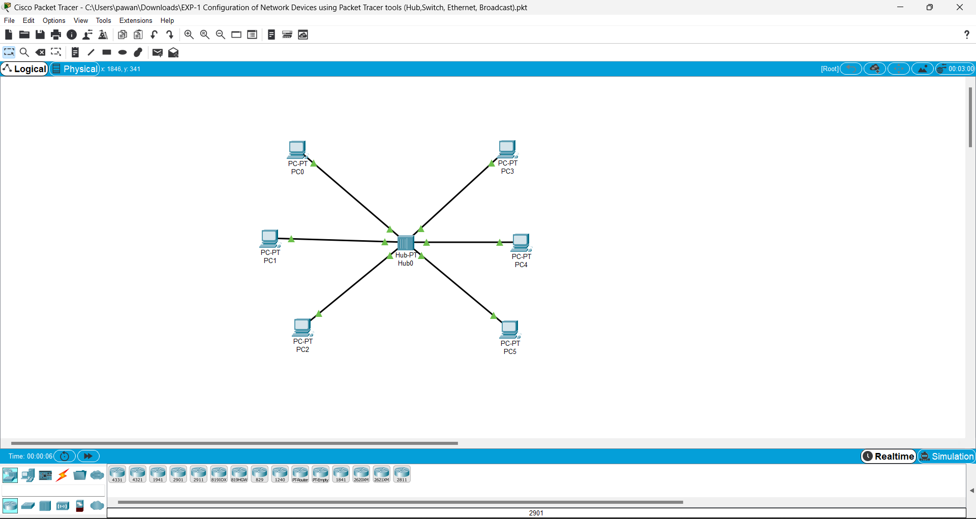

2

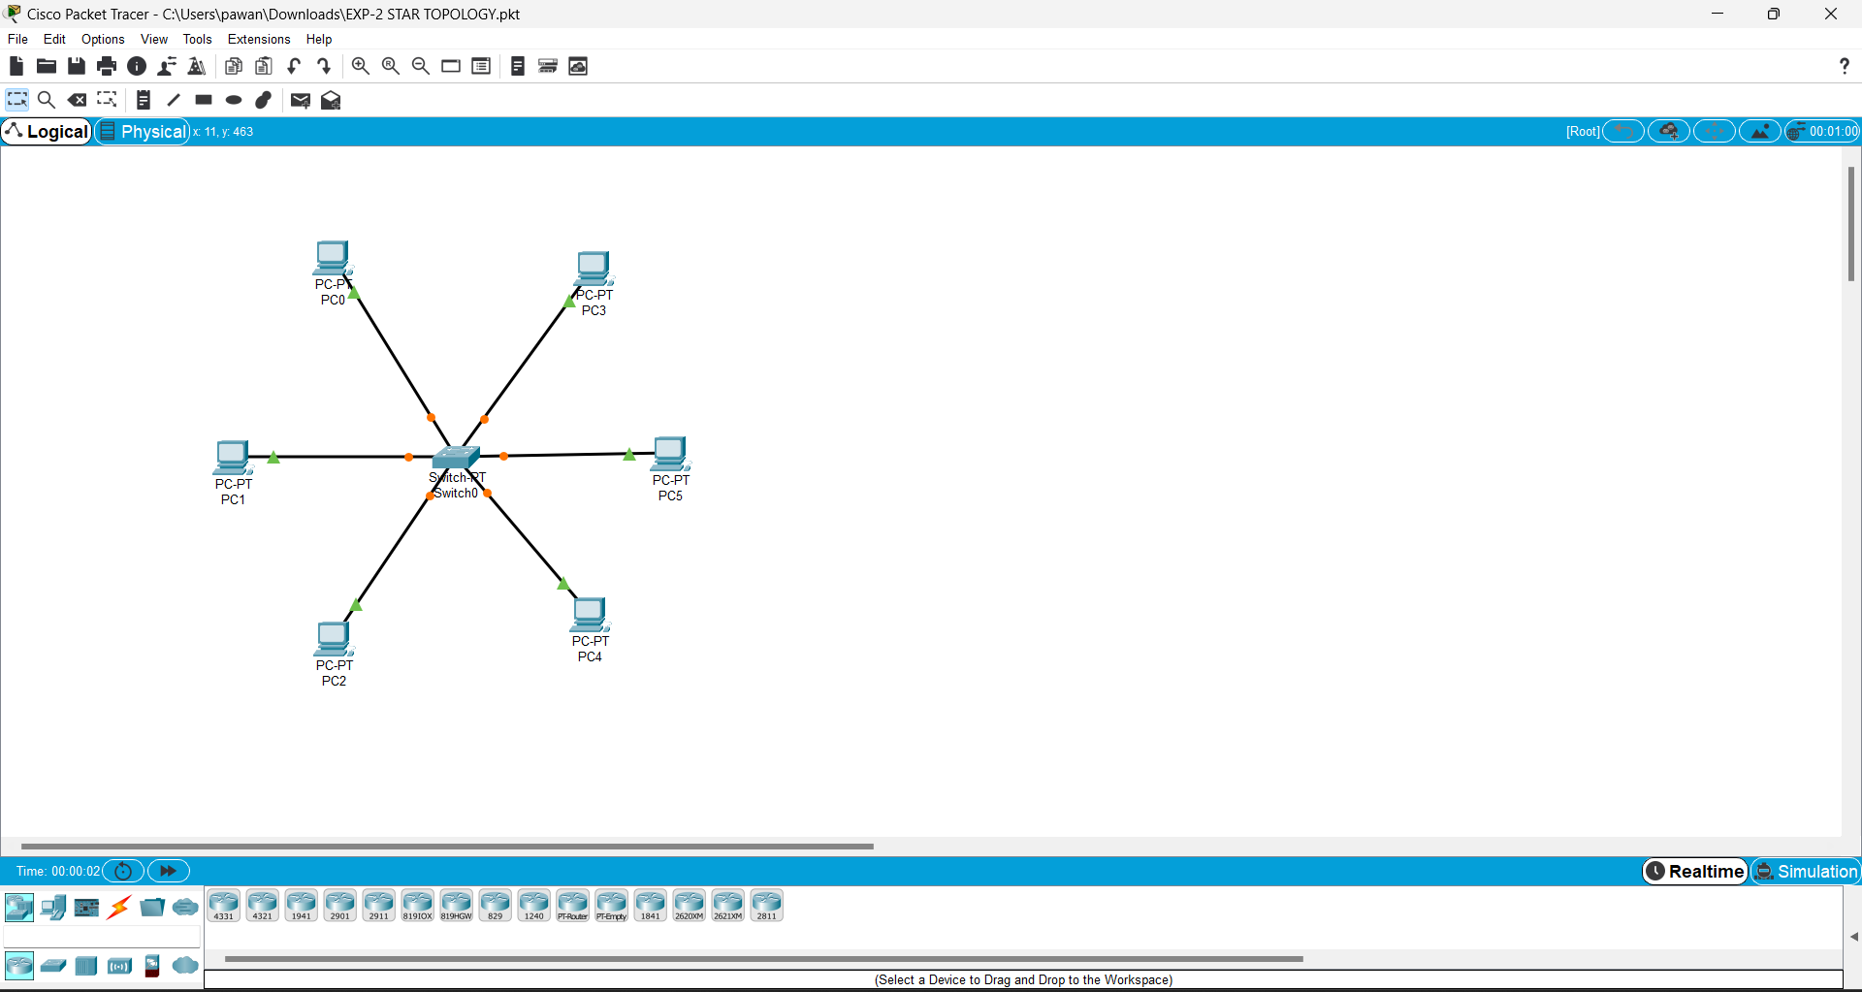

3

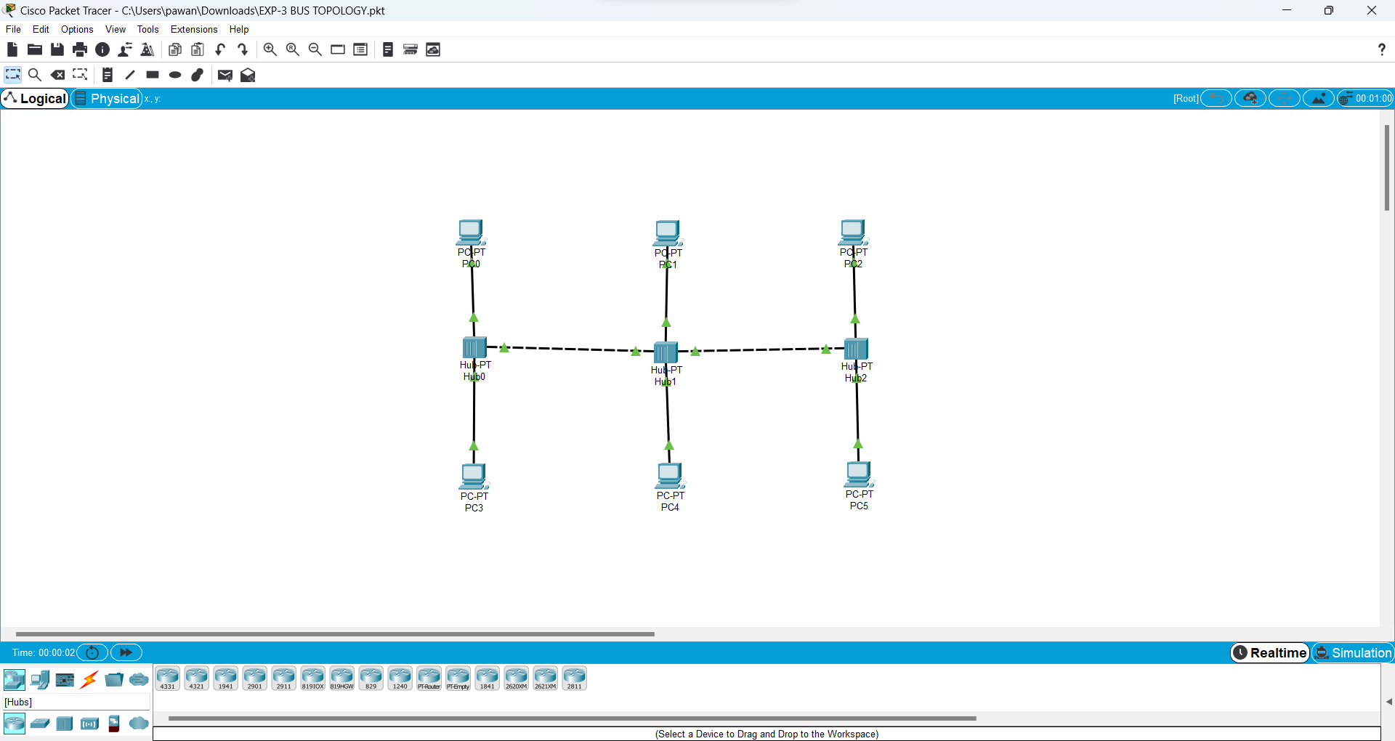

4

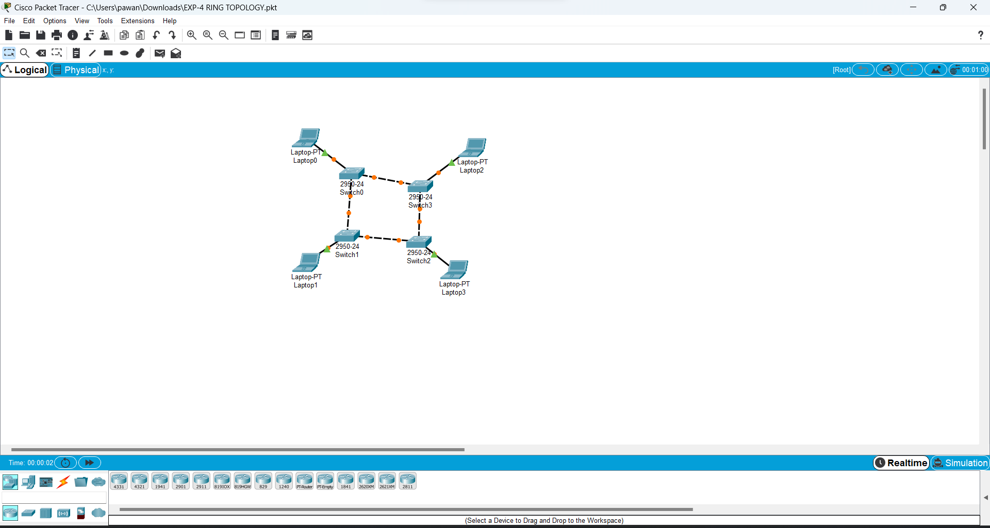

5

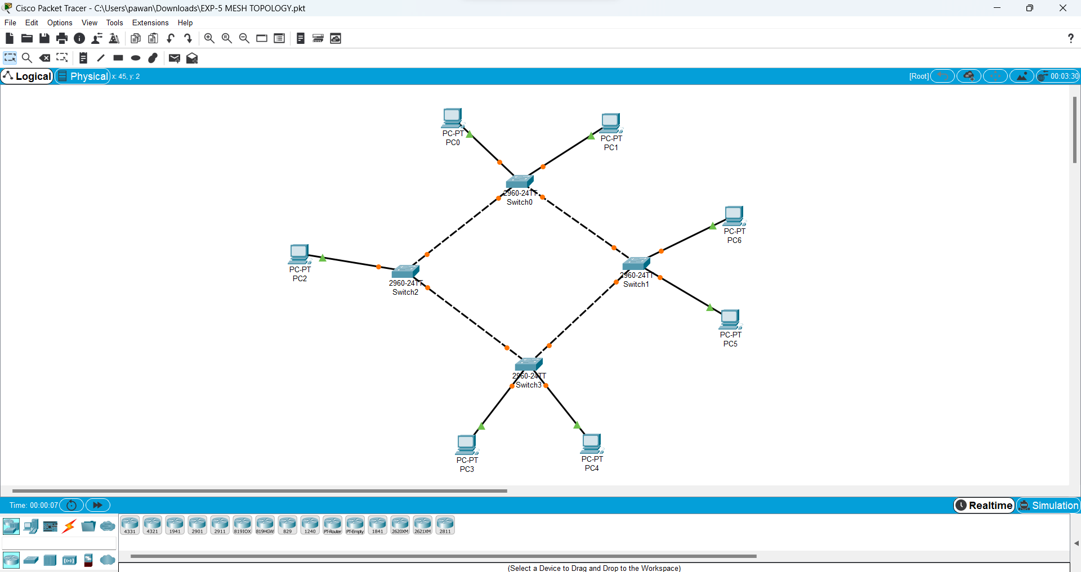

6

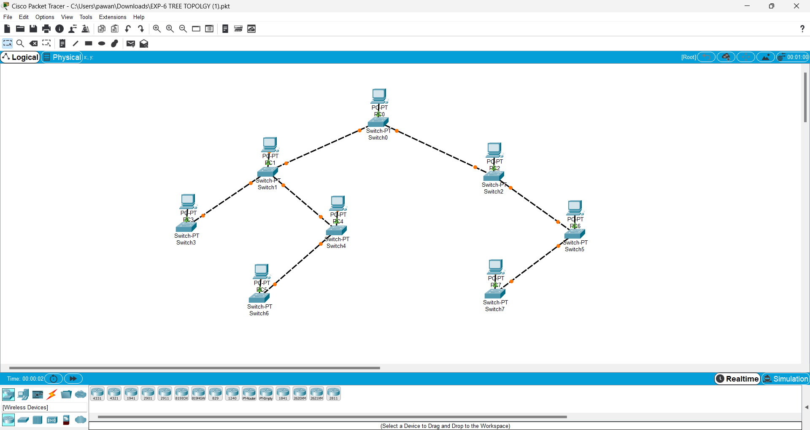

7

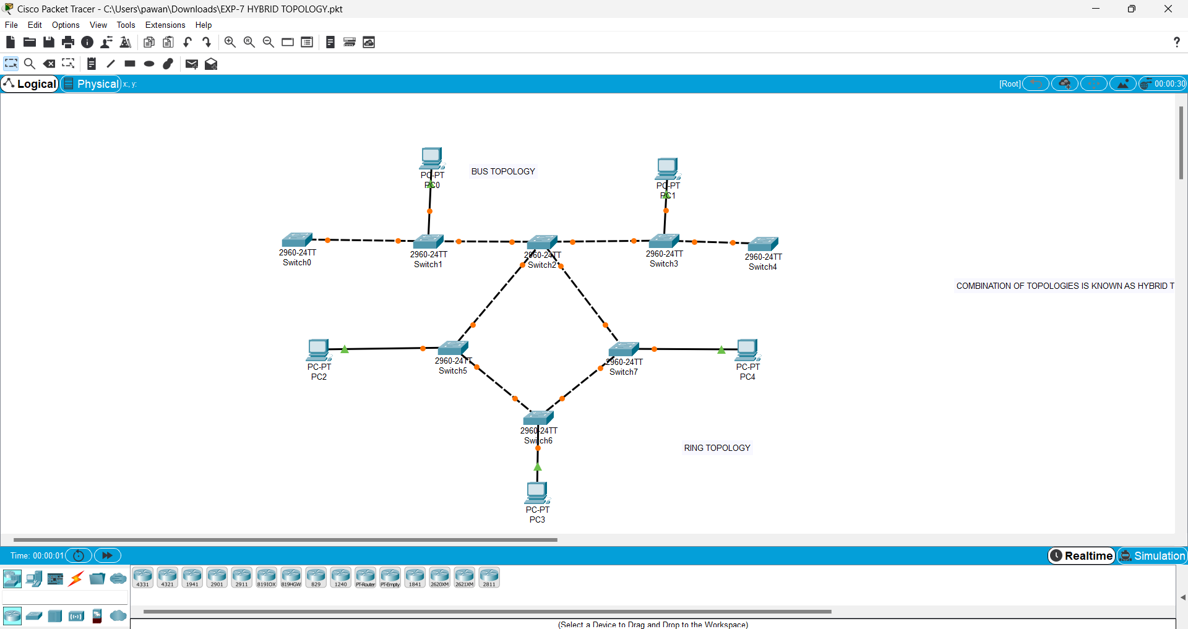

8

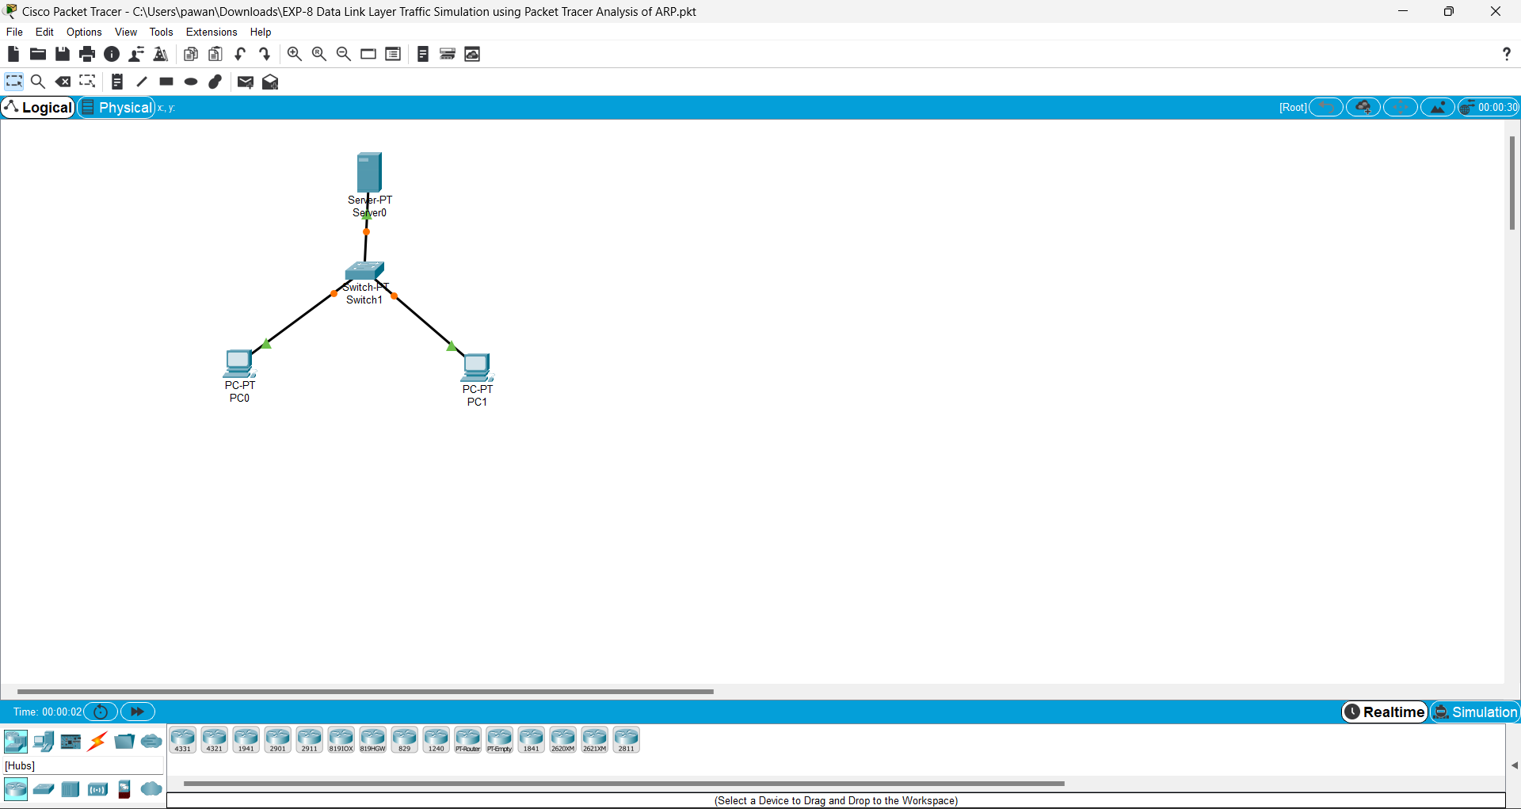

9

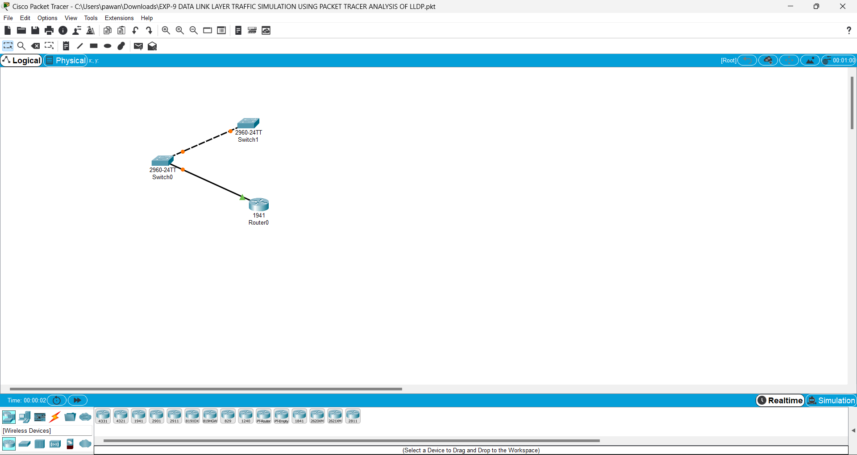

10

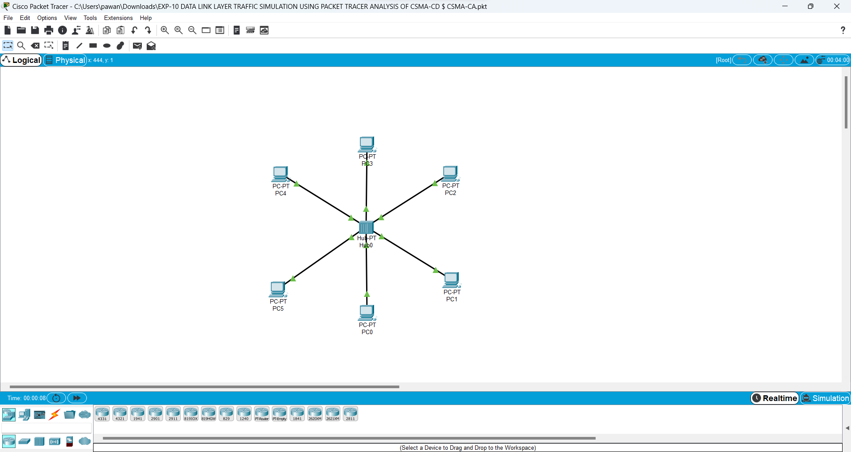

11. #include<stdio.h>

#include<string.h>

int main()

{

int a[20],b[30],i,j,k,count,n;

printf("Enter frame size (Example: 8):");

scanf("%d",&n);

printf("Enter the frame in the form of 0 and 1 :");

for(i=0; i<n; i++)

scanf("%d",&a[i]);

i=0;

count=1;

j=0;

while(i<n)

{

if(a[i]==1)

{

b[j]=a[i];

for(k=i+1; a[k]==1 && k<n && count<5; k++)

{

j++;

b[j]=a[k];

count++;

if(count==5)

{

j++;

b[j]=0;

}

i=k;

}

}

else

{

b[j]=a[i];

}

i++;

j++;

}

printf("After Bit Stuffing :");

for(i=0; i<j; i++)

printf("%d",b[i]);

return 0;

}

Enter frame size (Example: 8):12

Enter the frame in the form of 0 and 1 :0 1 0 1 1 1 1 1 1 0 0 1

After Bit Stuffing :0101111101001

12.

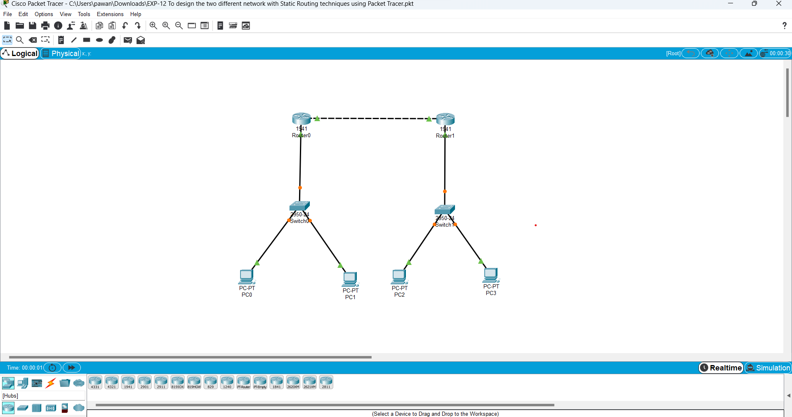

13

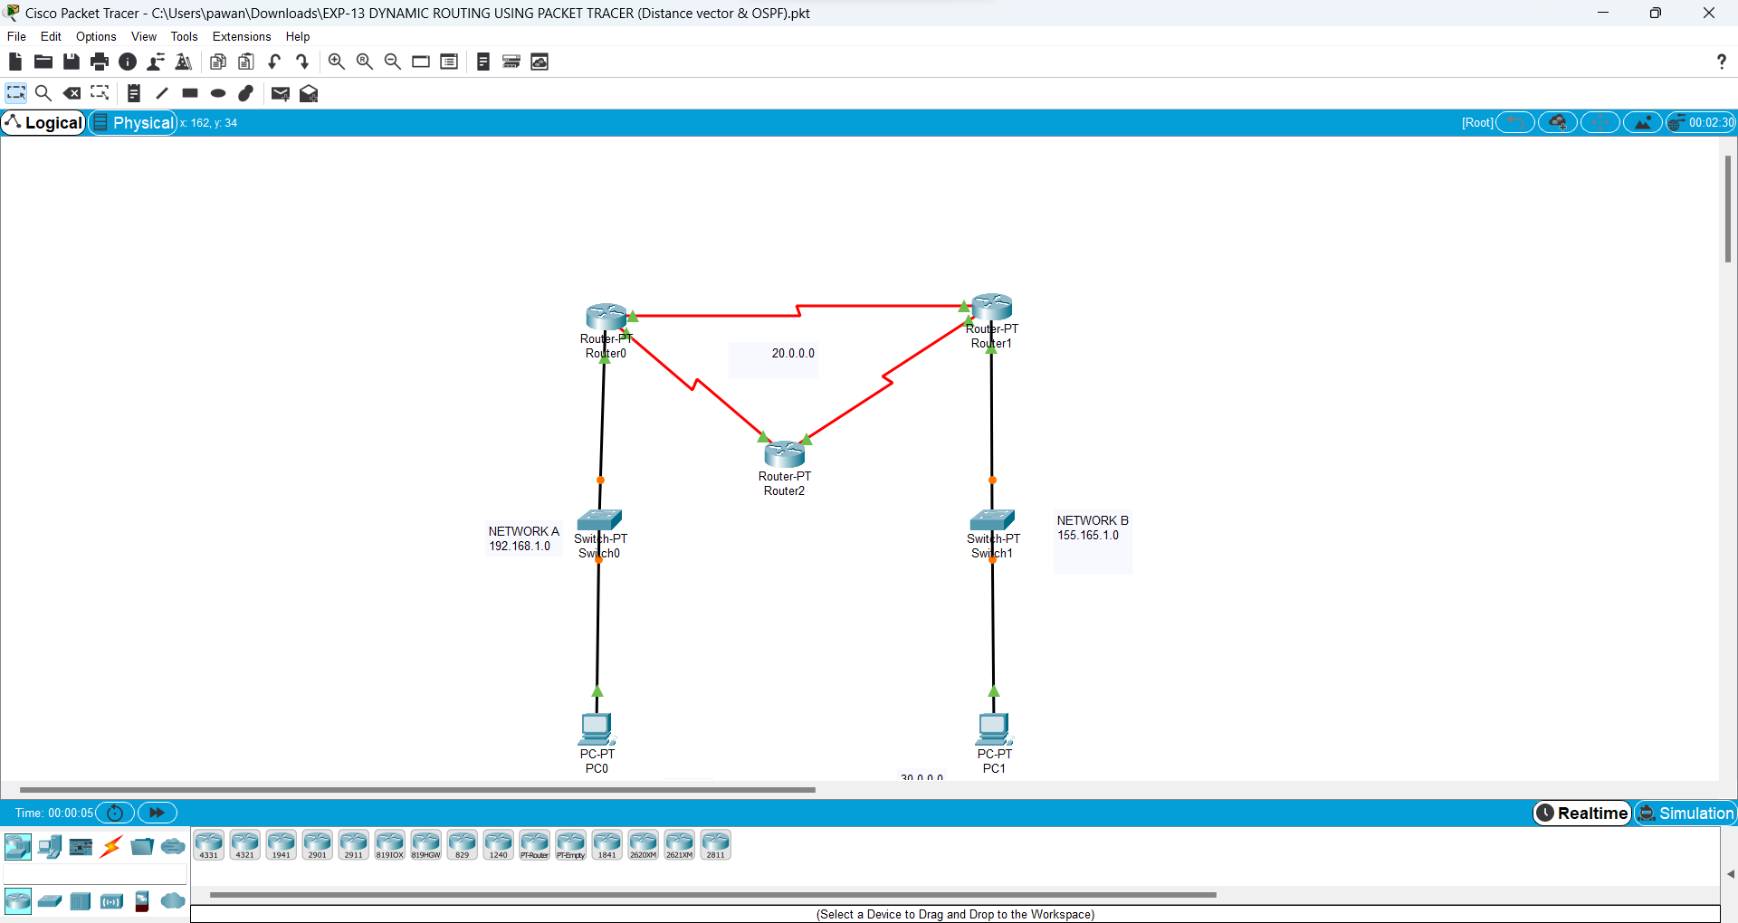

14

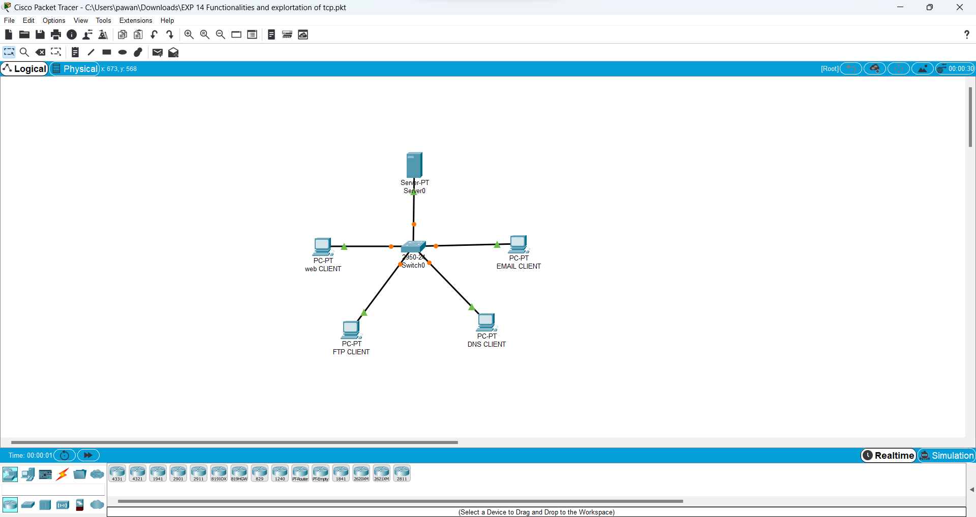

15

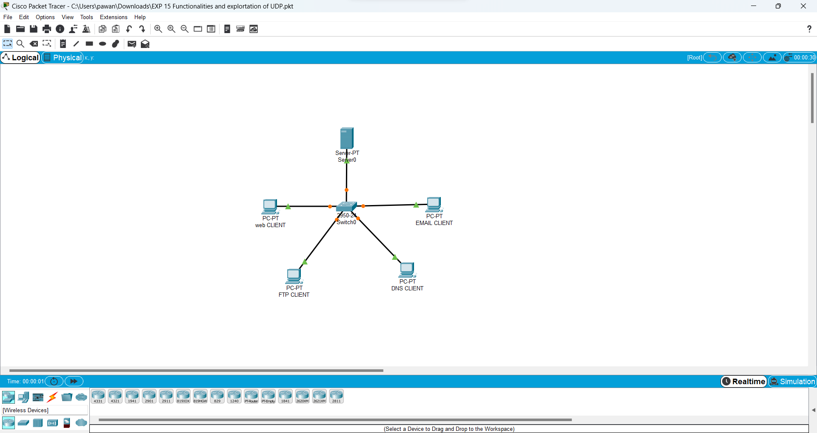

16

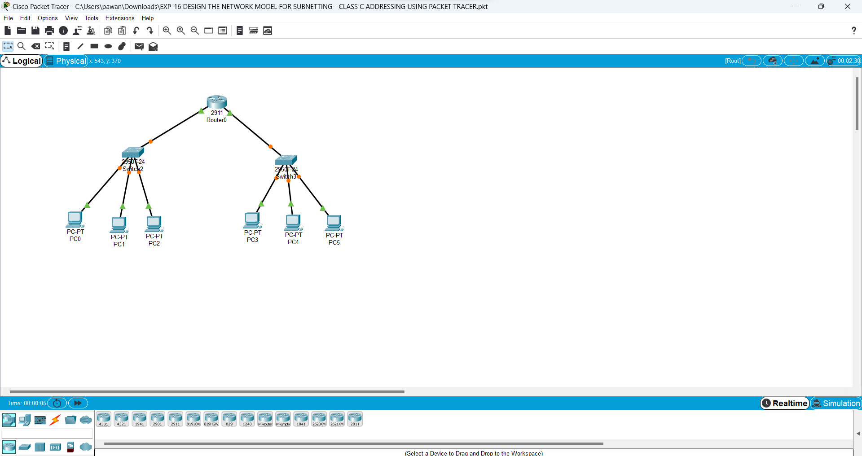

17

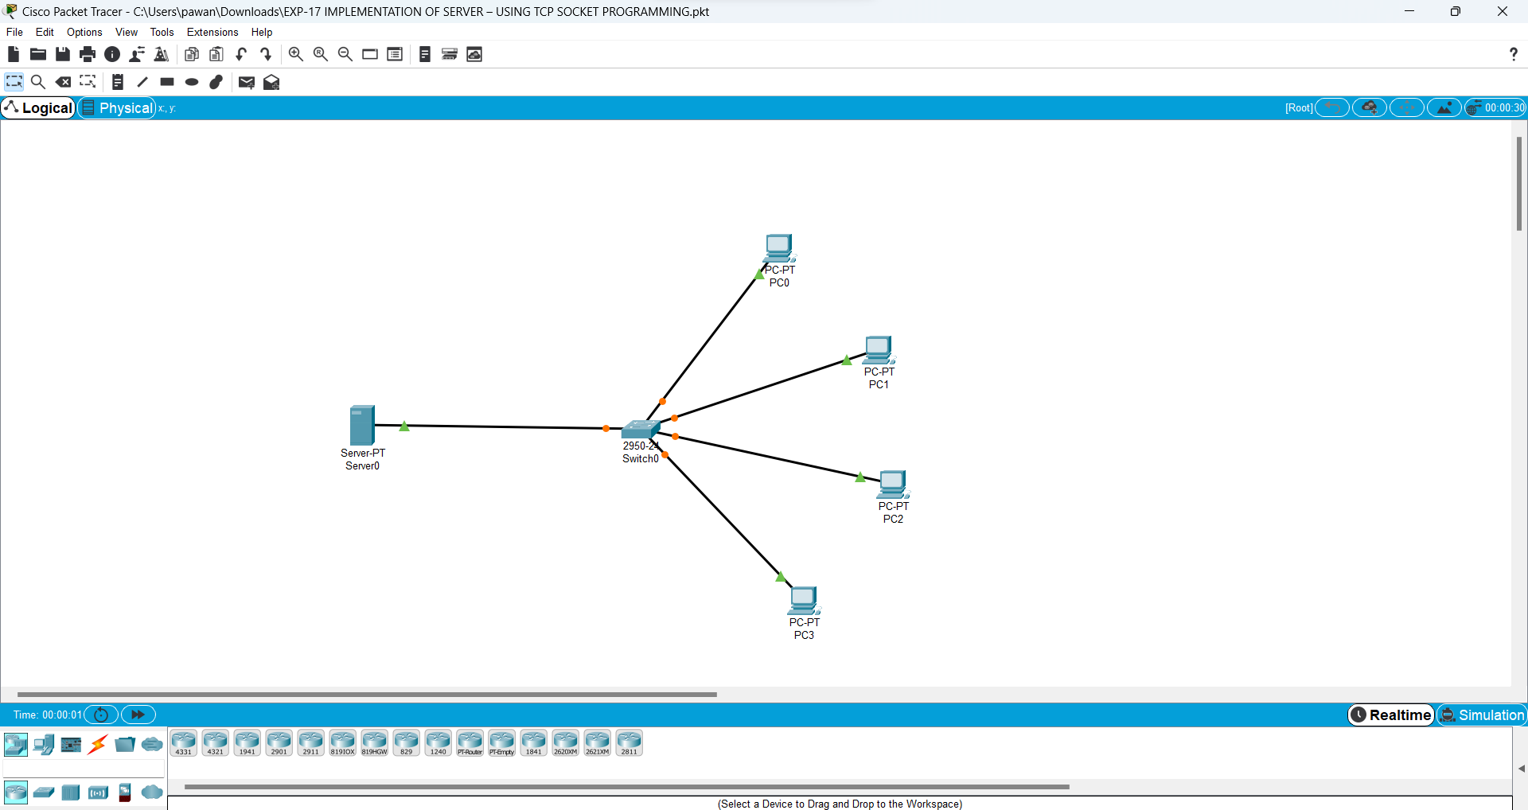

18

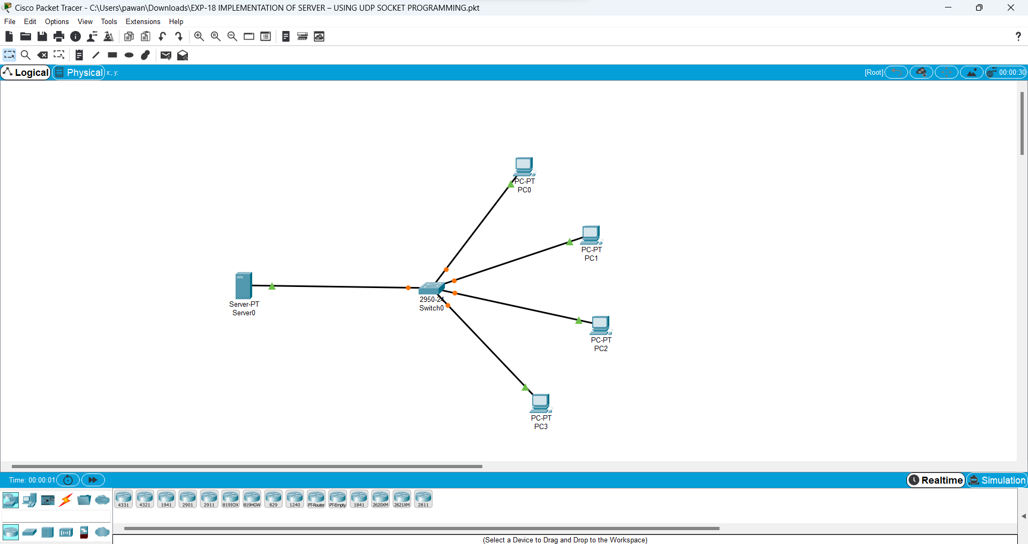

19

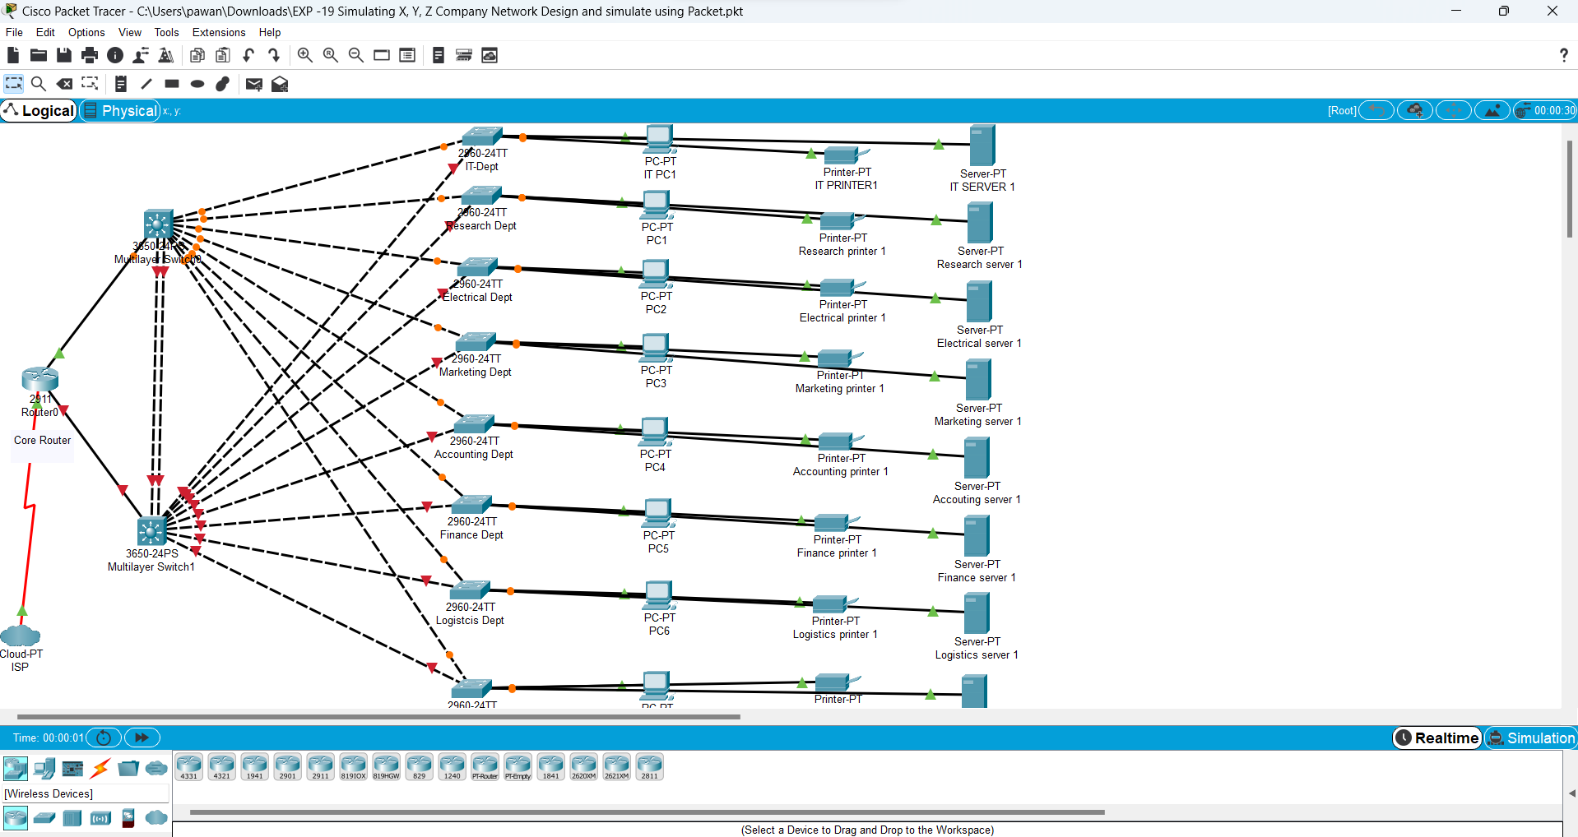

20

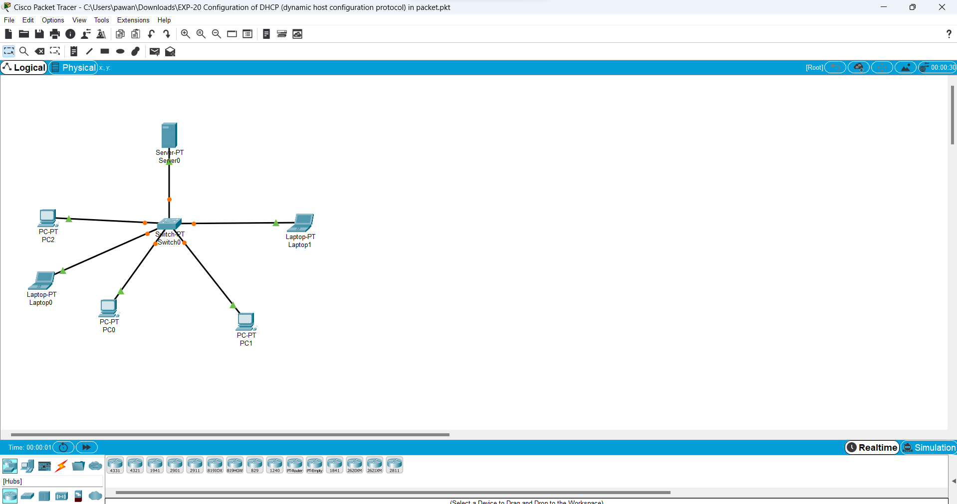

21

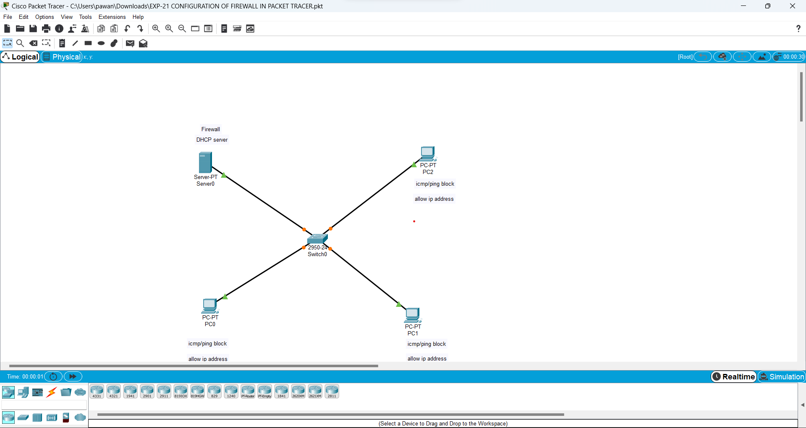

22

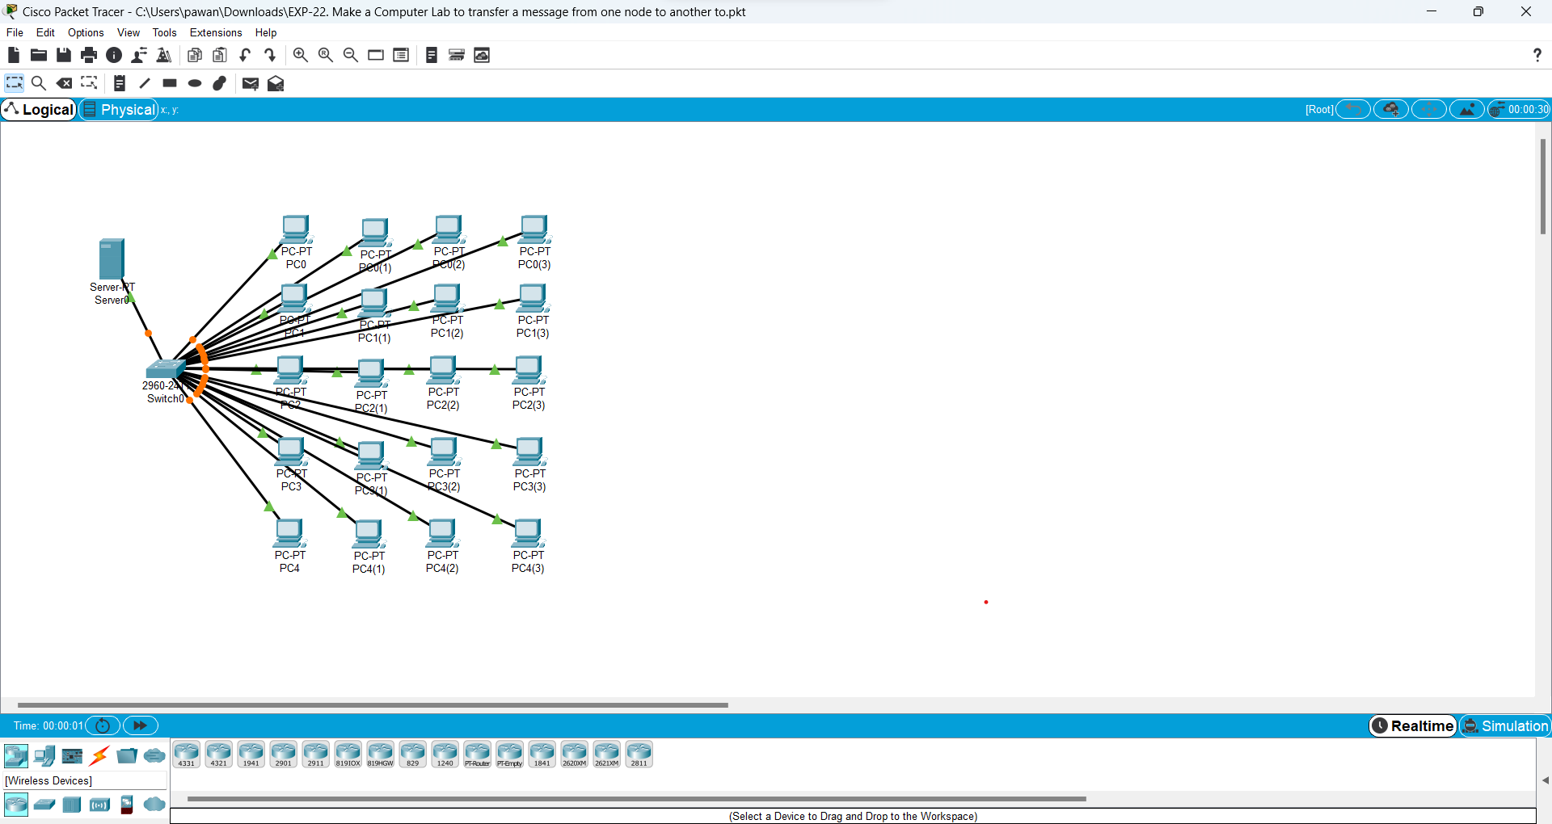

23

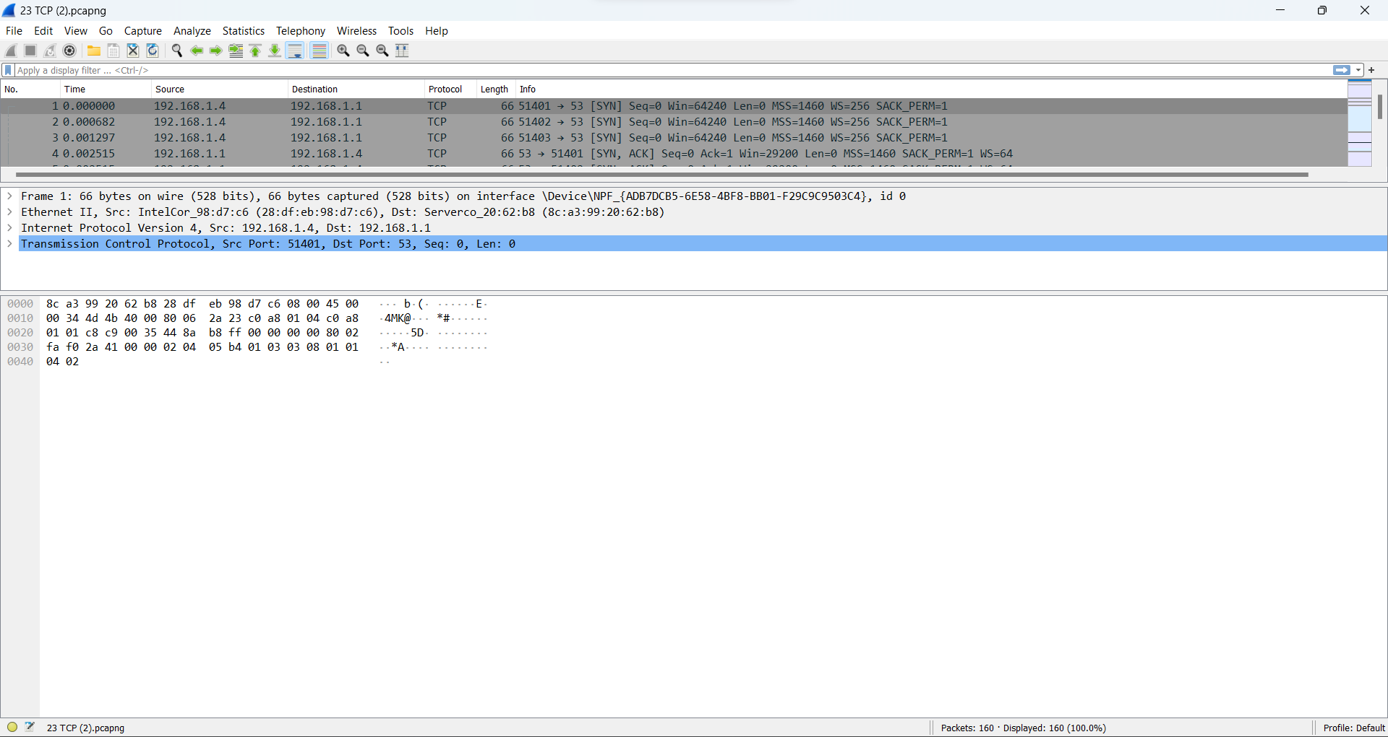

24

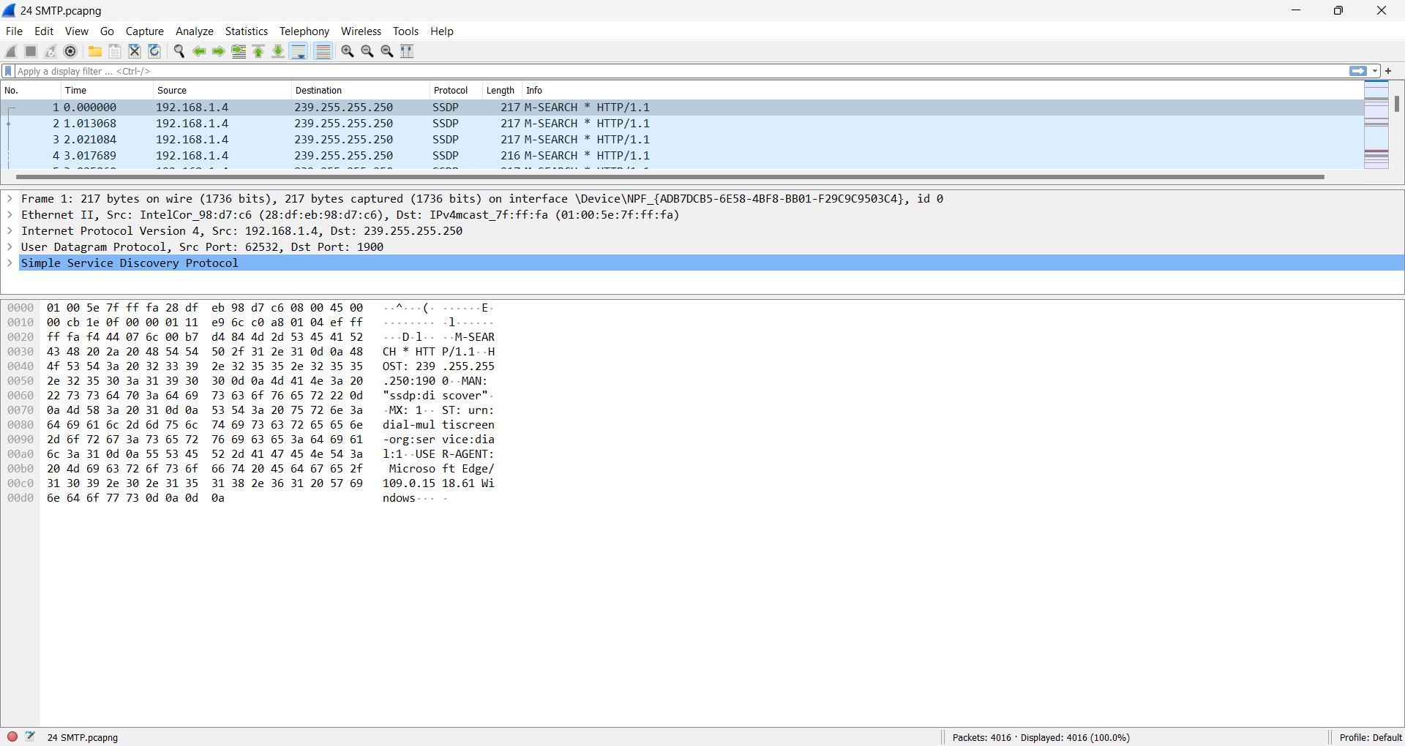

25

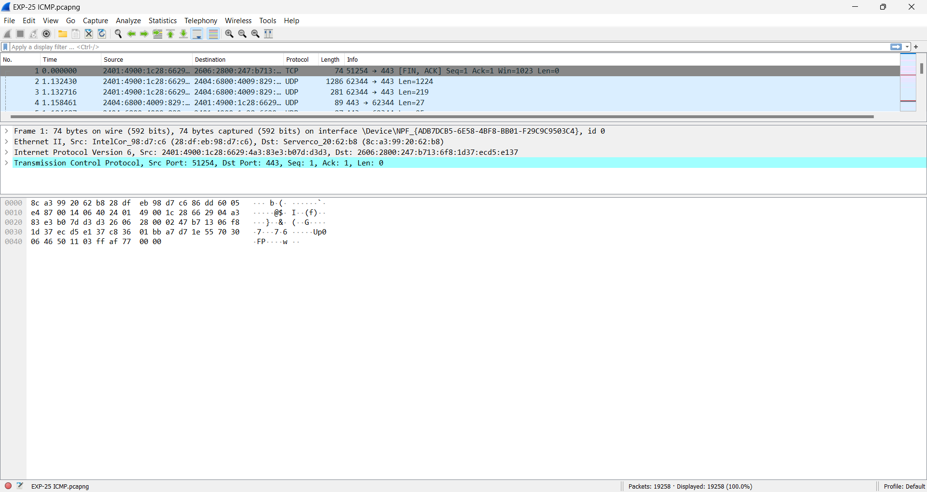

26

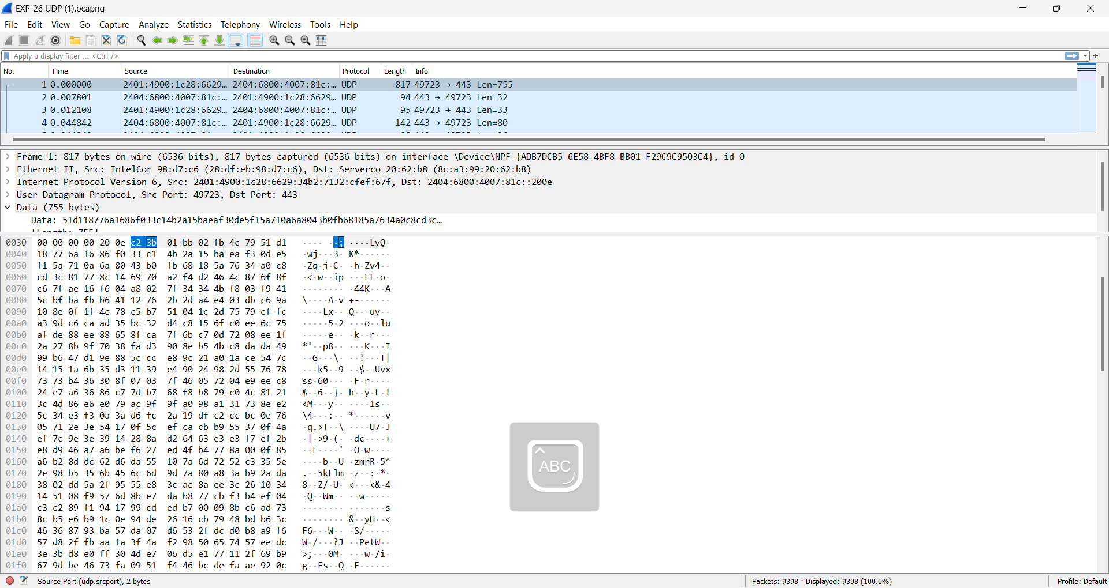

27

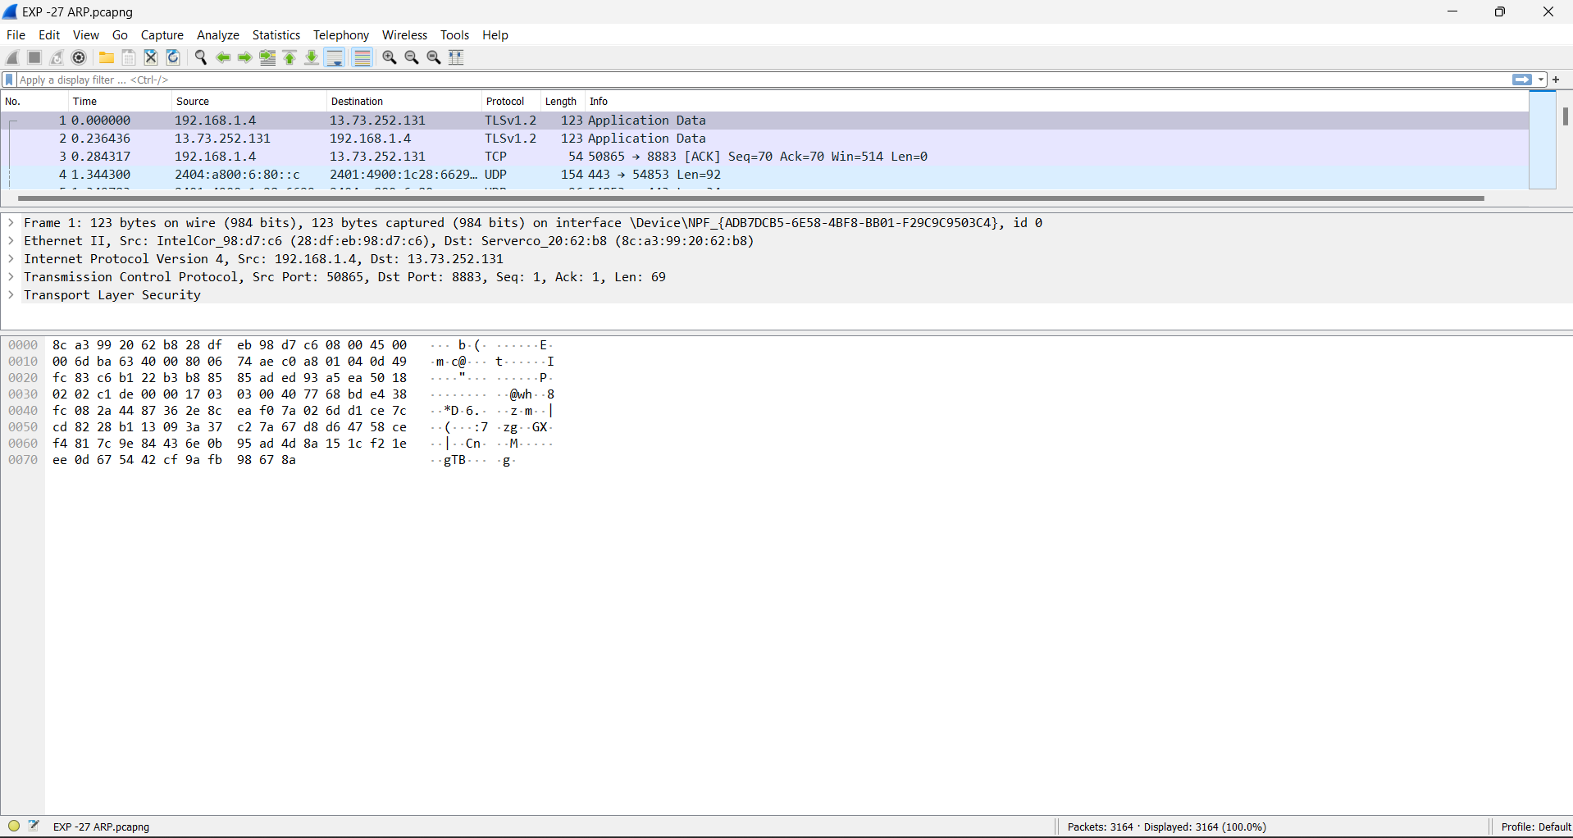

28

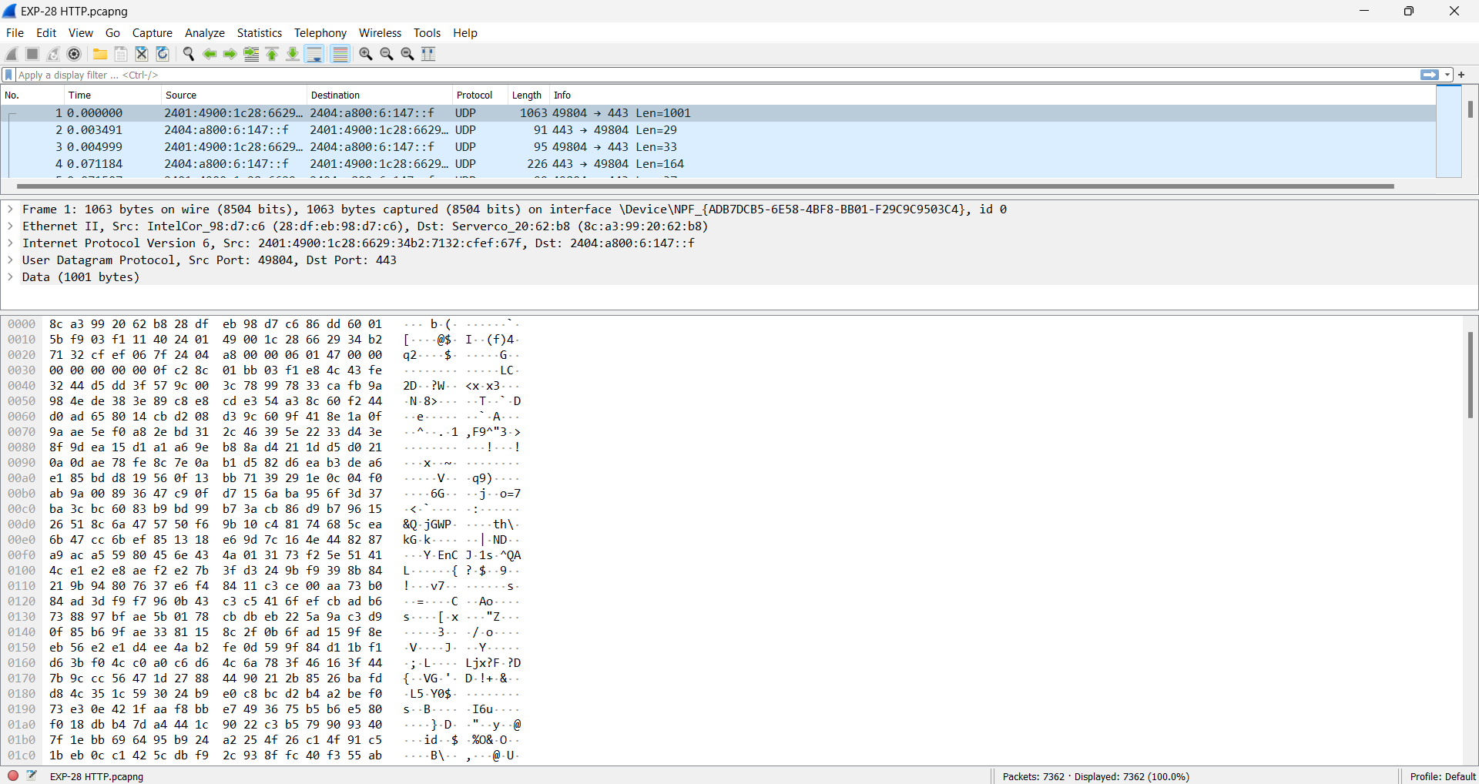

29

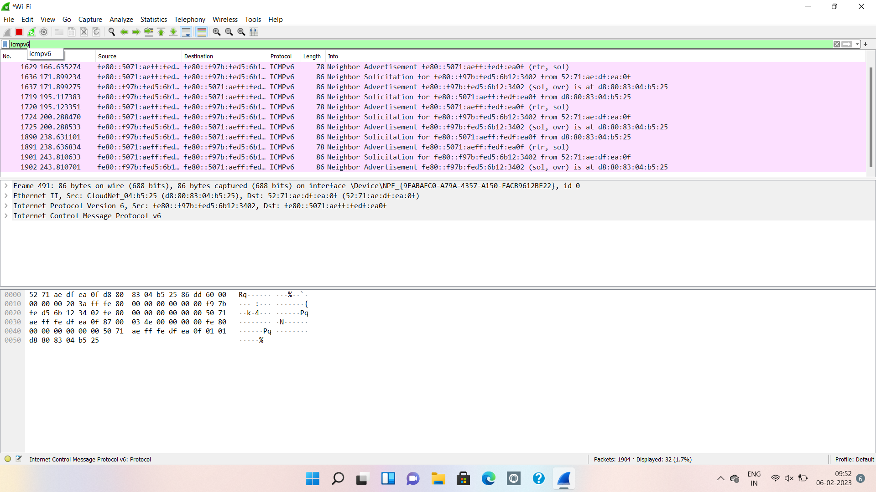

30

